**PCF8591 YL-40 AD DA Module Review**

Posted on [October 25, 2012](https://brainfyre.wordpress.com/2012/10/25/pcf8591-yl-40-ad-da-module-review/) by [Brainfyre](https://brainfyre.wordpress.com/author/brainfyre/" \o "View all posts by Brainfyre) — [13 Comments](https://brainfyre.wordpress.com/2012/10/25/pcf8591-yl-40-ad-da-module-review/#comments)

 10 Votes

**Summary**

This article describes the design and programming of the PCF8591 A/D-D/A module whose printed circuit board is labelled YL-40 . The module is shown in Figure 1, and its schematic diagram is shown in Figure 2. Note that several other, similar modules exist, but in different shapes and with different capabilities. All, however, are centered on the Philips PCF8591 Analog-to-Digital Converter (ADC) and Digital to Analog Converter (DAC). I noted that the 16-pin DIP form is now available; making it easier to prototype. Soldering SMD ICs to a PCB is not for the faint of heart, in my opinion.

[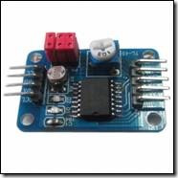](https://brainfyre.files.wordpress.com/2012/10/clip_image002.jpg)

Figure 1: PCF8591 Module YL-40

This particular module is suitable for tutorial use and perhaps for some hobbyists. Its drawback is that its I2C address is hard-wired to all zeros. (Note that I2C is a very effective 2-wire communications standard that is used by many small semiconductor devices such as microcontrollers and sensor peripherals.) If the address lines could be jumpered high or low, then several identical modules could be placed on the same I2C lines. I would therefore recommend the alternative module named the Mini PCF8591 AD DA Shell Module because it has that capability. It is also at least three times the price.

The IC permits only 8 bit data allowing only 256 steps in the analog output value or the digital output value. This is likely borderline for hobbyists who may want to build instrumentation or test equipment.

My tests show another frustration: A lower than expected analog output voltage. For a 4.88 volt supply the output is only 4.17 volts (85%) at maximum value setting. Since the maximum supply voltage is 8 volts, increasing the supply to 6 volts may get a 5 volt result. I did not remove the green LED and related resistor to see if the problem was simply an excess current drain from the IC’s AOUT.

Reference: PCF8591 8-bit A/D and D/A converter Product Specification, 2003-01-27, Philips Semiconductor.

**PCF8591 Module YL-40**

The module is composed of:

* A PCF8591 IC at U1.
* A thermistor that measures temperature at R6.
* A photo-voltaic cell. This is a light sensitive resistor at R7.
* A single turn trimmer potentiometer at R3.
* Two LEDs: a red one that is on when the device has power; and a green one that increases brightness as the output voltage increases.
* Three red jumpers that apply the voltage sources – photo-voltaic cell, thermistor, and potentiometer, and to analog input channels AIN0, AIN1, and AIN3 respectively.
* Connector pins for I2C (SDA and SCL), Vcc, and ground.
* Connector pins for the Analog output AOUT, and pins for each of the three analog input channels.
* A 4-wire ribbon cable is included with sockets suitable for the connector pins.

[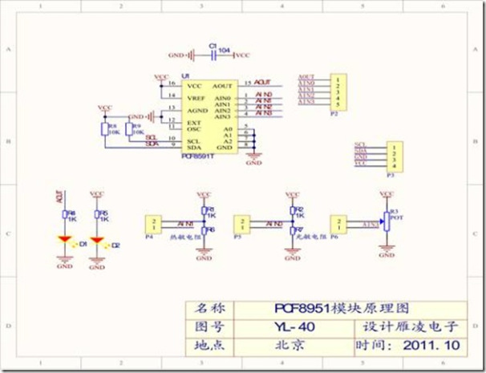](https://brainfyre.files.wordpress.com/2012/10/clip_image0023.jpg)

Figure 2: YL_40 Schematic

The jumpers control whether analog input channels of the IC are connected to the analog sources:

* Jumper P4 for AIN1: The temperature sensed by the R6 thermister is provided to the ADC.
* Jumper P5 to AIN0: The R7 photocell voltage (resistance drop) is provided to the DAC.
* Jumper P6 to AIN3: The single turn 10K ohm trimpot voltage (resistance drop – brighter light, lower resistance).

Removing a jumper allows an input channel to be fed from one of the external pins, labelled accordingly.